UChicago Arts Box Office
Ticket Printing Request Form (Student Organizations)

General Information
Organization:
Main Contact Name:
Email:
Phone:
Second Contact Name:
Email:
Phone:
Advisor:

Date/Time of the ticketed Event(s):

Event Venue/Space Location:

Event Title:

Ticket Prices:
(Student/General Admission/Adult/Child etc.)

Total number of tickets you wish to have printed:

Seat Break Down:
(General Admission versus Reserved. If reserved, please specify a seating configuration.)

Ticket design:
(Is there any additional details you wish to have printed on the ticket beyond what is featured on the sample below?)
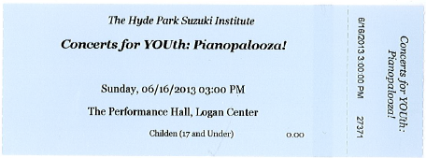

University Account # to bill the charges to:
(Full account number should be a total of 10 digits, including the 4 digit sub account number.)

